# Year 12 Statistics

# Evaluating a statistical report

# 2 credits

# 

# Name:_____________

What is a statistical report?

A statistical report is a way to communicate the results of either an **observational study** from which we can make **inferences:**

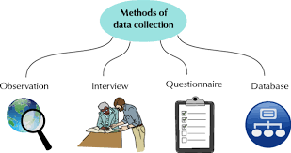 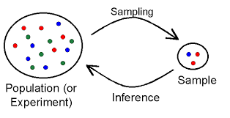

Or an **experiment** from which we can show **cause and effect**.

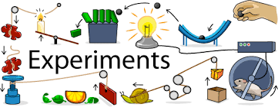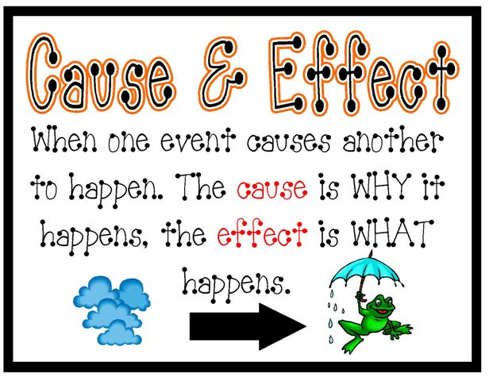

The difference between these is due to the **random allocation**:

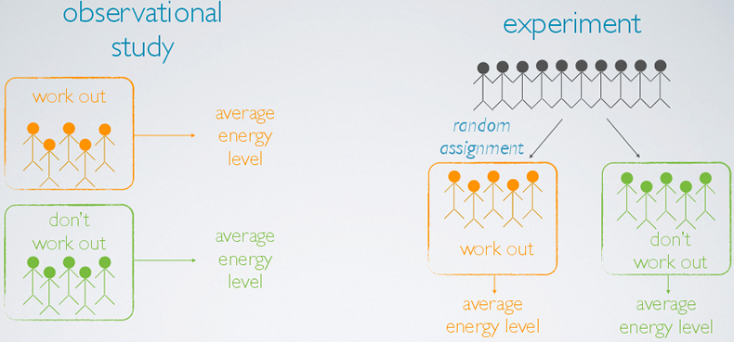

**Most statistical reports are about observational studies.**

**Exercise:**

What is an observational study?

What is an experiment?

Here are some examples of who produces statistical reports:

Companies: Governments:

 

News Media: Social Media:

 

Scientists: Researchers:

 

Purpose and Audience

Before we can look at what the investigation question is, we need to know what the purpose and audience are for the study – either an observational study, or an experimental study.

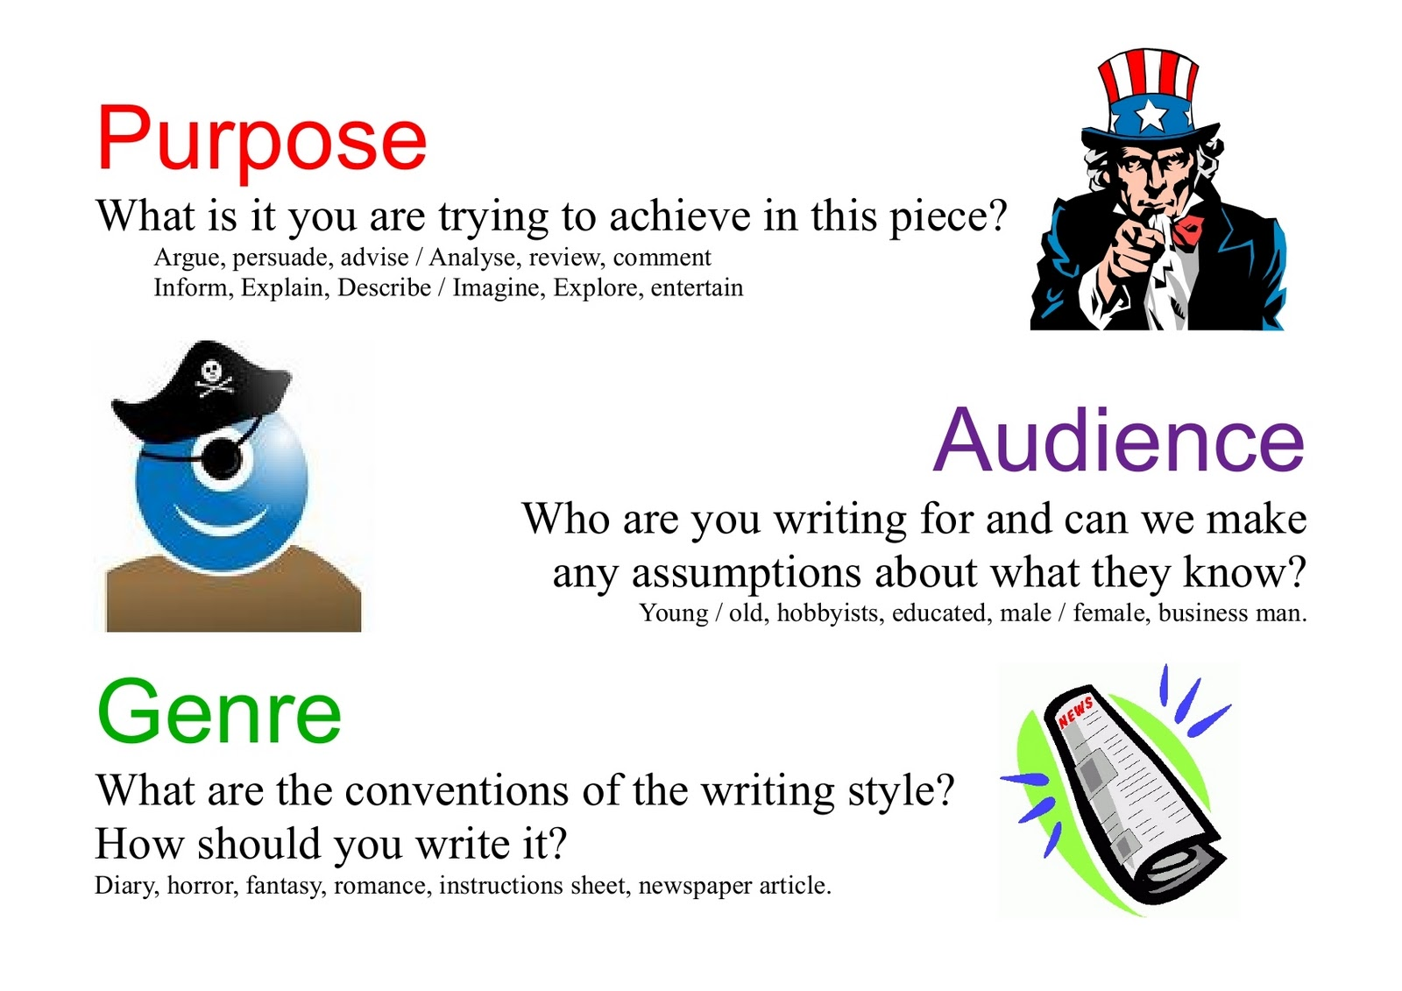

**Exercise:**

Why would someone write a statistical report?

(Hint: think about the people who write reports on the previous page.)



Why do we want to know who the author of a report is?



Why do we want to know who paid for the research?



Who or what is the audience of a report?



Sampling

Before the data can be collected, we need to have a plan of how we are going to collect it. This means we need to think about our **target population, sample frame,** and **respondents.**

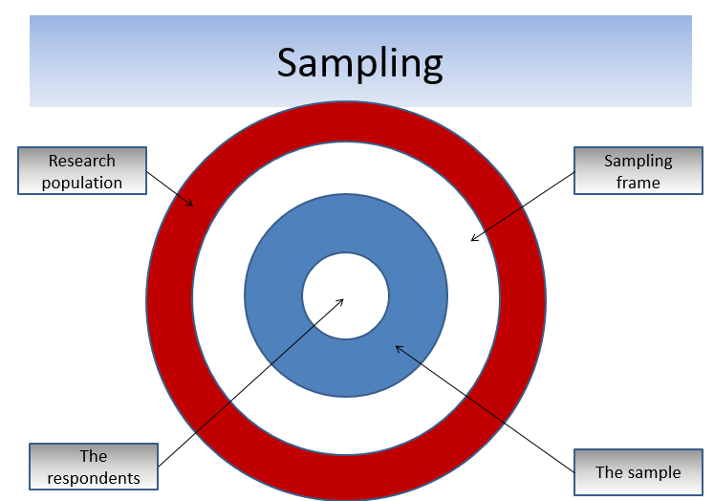

Here is an example, describing the population, sampling frame and sample.

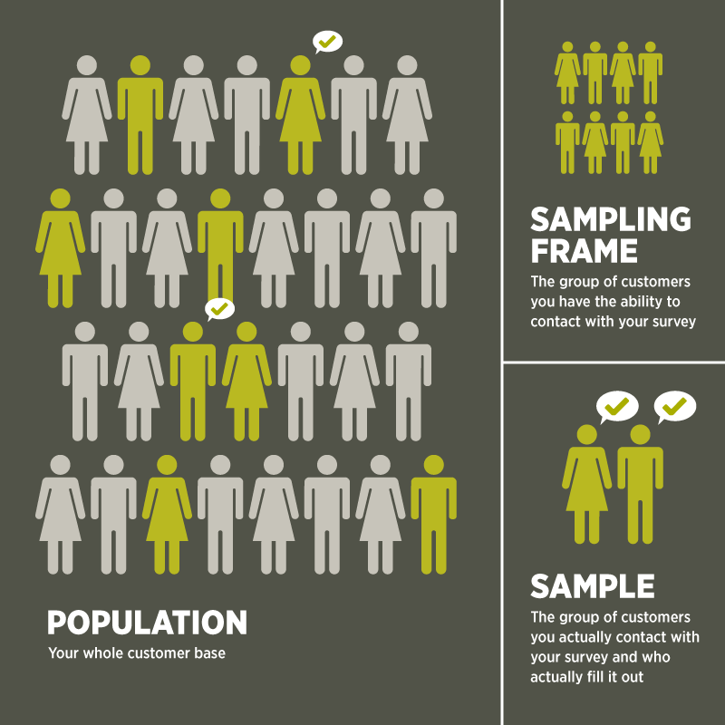

**Exercise:**

What is a target population?

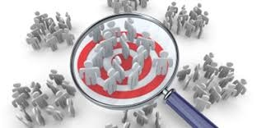

Can we always get a complete list of everyone in our target population? Why/why not? (Hint: can I get a list of all people who own a cell phone for example?)

What is a sampling frame?



What is a sample?

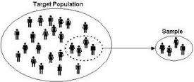

Does everyone you ask to do a survey agree to fill it in?

Who or what are respondents?

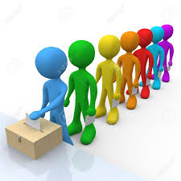

Extra for Excellence – Target Population

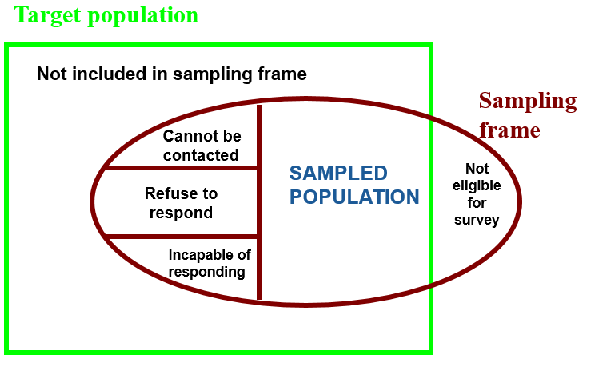

**Exercise – Extra for Excellence:**

If I am interested in taking a sample of Year 9 students in Coolock house, I would have to use a list of all Year 9 students in the school.

Classify students in the following situations, using the categories from the diagram:

* Students who have left McAuley.
* Students who aren’t at school on the day of the survey.
* Students who don’t want to fill in the survey.
* Students from Year 10.
* Students in the sick bay with the nurse.
* Students who come to school late.
* Students who are sitting an assessment.

Response Rate

The students who cannot be contacted, refuse to respond, or are incapable of responding are called **Non Respondents**. They may have opinions, values, measurements or information that is substantially different from our **Respondents.** This is why we try to maximise the **Response Rate**.

**Sample**

All people who were asked to do survey

**Respondents** – the people who completed the survey

**Non-Respondents** – the people who did not do the survey

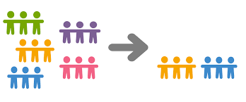

**Exercise:**

Complete the diagram below.

100 people were asked to fill in my survey, and 50 filled it in.

What does a response rate of 30% mean?

Is it better to have a high or low response rate? Explain.

If I have a low response rate, what does this say about the accuracy and quality of my data? Explain.

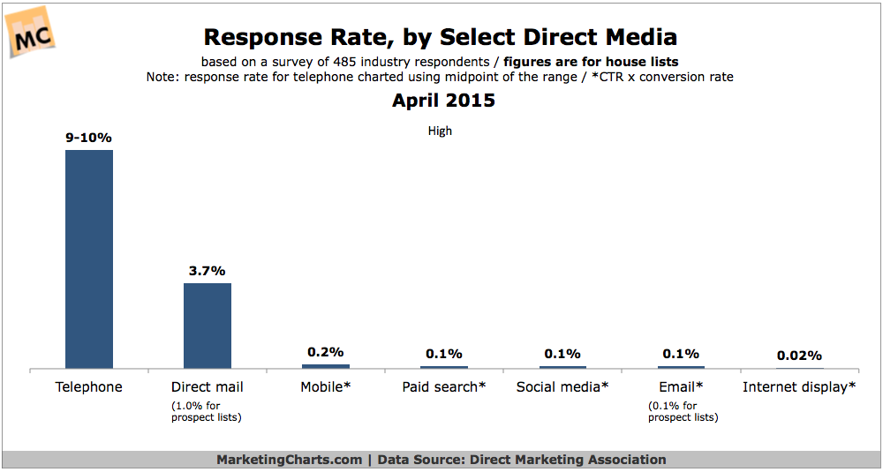

What does this graph say about the response rates for different data collection methods?

Survey errors

Sampling Error

As soon as we take a sample, we **will** have sampling error. It cannot be avoided.

If we were to take a census, we **DO NOT** have sampling error.

Here is an info graphic, which represents the 2013 Census results for NZ.

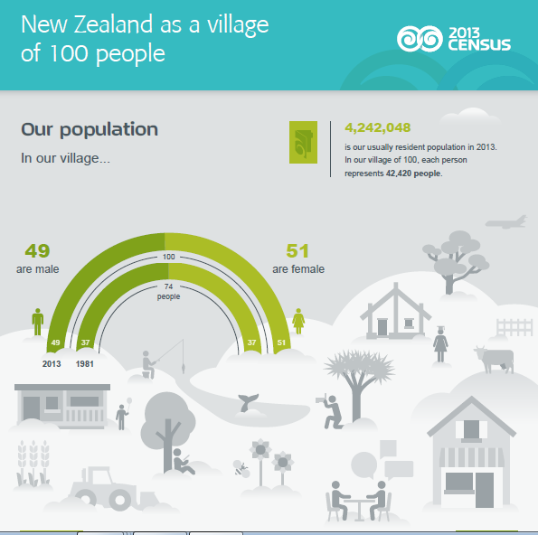

There are two main reasons we take a sample:

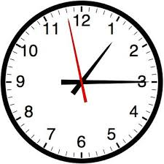

The time it takes to collect the data can be very long. For example, in a census it takes around 6 months to collect the data.



The amount of money it costs to collect the data. For example, the last NZ census in 2013, cost the country hundreds of millions of dollars.

**Exercise:**

What is a census?

If we take one sample, and then we take a second sample (see the diagram below), would we collect the same data? Would we get the same results? Explain why/why not.

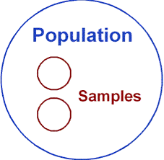

This difference in results (mean, median, IQR, standard deviation, etc.) for each sample we take, is **sampling error**.

**Sampling error** is the difference between an **estimate** of a population parameter and the **true**, but unknown, value of the population parameter (e.g. mean, median etc.).

Non-Sampling Errors

**Non-Sampling error is** the error that arises in a data collection process as a result of factors other than taking a sample.

Non-sampling errors have the potential to cause bias in polls, surveys or samples.

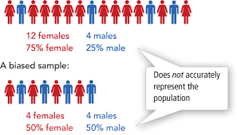

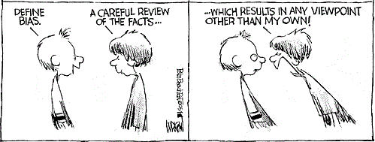

The key idea is that we want data that is **representative**.

A **representative sample** is one in which the relevant characteristics of the sample members are generally the same as the characteristics of the population. E.g. gender, ethnicity, age, income levels, etc.

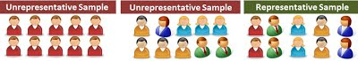

Types of Non-Sampling Error

**Exercise:**

What is bias?

Why do we want representative data?

What type of non-sampling error is shown in this cartoon?

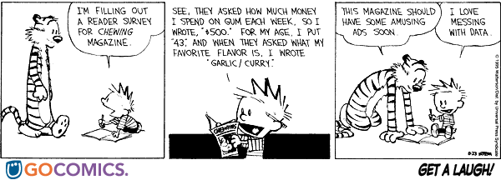

Does having non-sampling errors affect the quality and accuracy of our data? Explain.

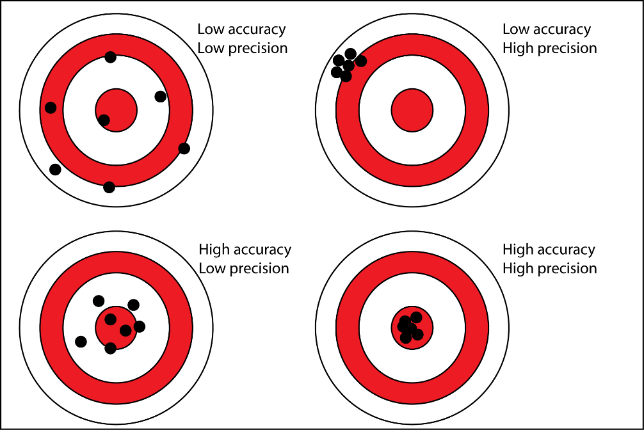

Describe some ways that we can minimise or reduce the amount of non-sampling errors present in a survey.

Sampling method

There are several sampling methods that we have learnt this year:

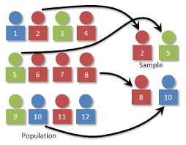

The good sampling methods are:

* **Simple random sampling**.

Every member of the population has the same chance at being selected.

* 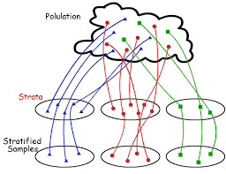**Stratified sampling.**

With stratified sampling, the population is divided into groups, based on some characteristic. Then, within each group, a probability sample (often a simple random sample) is selected. In stratified sampling, the groups are called strata.

* 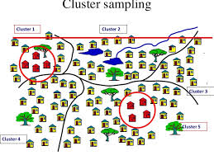**Cluster sampling.**

With cluster sampling, every member of the population is assigned to one, and only one, group. Each group is called a cluster. A sample of clusters is chosen, using a probability method (often simple random sampling). Only individuals within sampled clusters are surveyed.

* 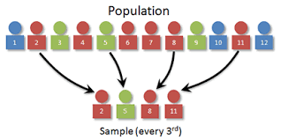**Systematic random sampling.**

With systematic random sampling, we create a list of every member of the population. From the list, we randomly select the first sample element from the first k elements on the population list. Thereafter, we select every kth element on the list.

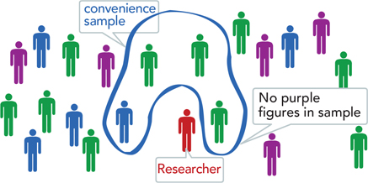Other non-random sampling methods are:

* **Convenience sample.**

This is made up of people who are easy to reach.

* **Self-selected sample.**

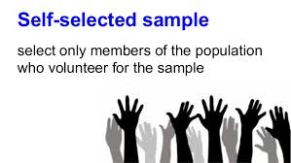This is made up of people who self-select into the survey. Often, these folks have a strong interest in the main topic of the survey.

**Exercise:**

What is a random sample?

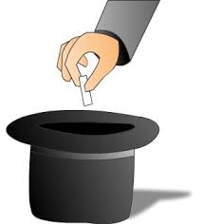

Why do we want to have a random sample?

Which of the methods mentioned above are good methods that will give us a representative sample?

Survey Method

A survey method is the method you use to give out your survey. You can choose from:

* Interview:
  + Face-to-face
  + Telephone
* Self-administered
  + Online
  + Email
  + Postal

**Exercise:**

Here is a list of advantages or disadvantages for the different survey methods. Match them to the methods in the table on the next page.

(Hint: some advantages/disadvantages can be used more than once.)

* Low Cost.
* High Cost.
* Takes a long time to collect the data.
* Takes a short time to collect the data.
* Low response rate.
* High response rate.
* Questions have to be short and simple.
* Questions can be more complex.
* Can collect data from a wide area (e.g. top of North Island to the bottom of south island).
* Can collect data from a small area.
* Get high quality responses from respondents (particularly on sensitive topics).
* Data may be incorrect.
* Surveys can involve video, animations and other forms of media.

|  |  |  |
| --- | --- | --- |
| **Method** | **Advantages** | **Disadvantages** |
| Written  questionnaire |  |  |
| Internet or email  questionnaire |  |  |
| Face-to-face  interview |  |  |
| Telephone  interview |  |  |

.

Sample Size

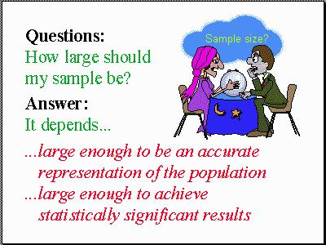

We need enough data for our results to be accurate, but need to balance how long it takes to collect our data.

If we have a small sample, our results won’t be very accurate, but it will take only a short time to collect the data (and only cost a small amount of money).

If we have a large sample, our results will be much more accurate, but it will take a long time to collect the data (and will cost a lot more money).

For **discrete (count)** data, we need a sample size of at **least 50**, to be accurate enough and not take too long to collect the data.

For **continuous (measurement)** data, we need a sample size of at **least 30**.

Measurement data is more accurate than count data, because the data values are more accurate (e.g. 12.3cm, 13.6cm, compared with 11, 12, 13), so this is why we need a bigger sample for count data than measurement data.

**Exercise:**

What is the minimum sample size needed for count data?

What is the minimum sample size needed for measurement data?

Is it better to have a small sample or large sample? Explain.

When your sample size increases, what happens to your accuracy?

Conclusion

Do conclusions from a questionnaire need to accurate? Explain why/why not.

Why do some companies, scientists, politicians, or other people try to mislead people with incorrect data, graphs, and conclusions?

Should we trust everything that is ever written in a newspaper, magazine, website, journal, book, etc.?

How can we decide whether or not we trust a statistical report?

Evaluation Framework for Statistical Reports

|  |  |
| --- | --- |
| **Title –** | |
| **Source of statistically based report** | |
| **Purpose of the report** | |
| **Summary of the report – a one paragraph summary of the report, including the purpose of the report and identification of the population of interest.** | |
| **A description of measures and variables representations.** | **Evaluation** |
| **A description of sampling method(s).** | **Evaluation** |
| **A description of survey method(s).** | **Evaluation** |
| **A description of the sampling and possible non-sampling errors.** | **Evaluation** |
| **A description of the sample size** | **Evaluation** |
| **An evaluation of the findings of the survey.** | |
| **An overall evaluation of the effectiveness of the statistically based report.** | |

Achieved level exemplar

Article: Most-trusted Brands

**Purpose:**

The purpose of the survey is to rate the brands that people in Australia trust the most. The company “Readers Digest” paid for the survey, and employed an independent research company “The leading edge” to carry out and analyse the survey. This was done in 2009.

**Evaluate Feature 1:**

One thing that I noticed was that the survey asked 750 people for their ratings of which brand they trusted the most. I think that a sample size of 750 is quite good, as it will give a range of opinions and is more than the minimum 50 we need for count data.

**Evaluate Feature 2:**

Another thing I noticed was that they didn’t tell us how they collected the data. Did they do it over the phone, or in person face-to-face, or on the internet? If I knew this I would be better able to evaluate whether I trust the results or not.

**Evaluate Feature 3:**

A third thing I noticed was that there were 158 brands selected out of 17 categories. Some people will have become bored and not ranked all 158 brands, so there will be missing data.

**Conclusion**:

We don’t completely trust the results from this survey because there wasn’t enough information shown (e.g. sampling method) for us to be able to trust it.

|  |  |  |  |
| --- | --- | --- | --- |
|  | **Achievement** | **Merit** | **Excellence** |
| ***Evaluate a statistically based report***involves identifying and commenting on features and findings of a survey relevant to the report’s purpose. | ***Evaluate a statistically based report, with justification***involves supporting the comments on the features and findings with reference to statistical evidence and the statistical processes used to carry out the survey. | ***Evaluate a statistically based report, with statistical insight***involves integrating statistical and contextual information to assess the quality of the report in terms of its purpose. |
| Purpose | Identify a purpose | Identify the key purpose | Identify key purpose and connect it to a wider context |
| Features | 1st feature evaluated: | 1st key feature evaluated with respect to the purpose | 1st feature limitation or improvement discussed |
| 2nd feature evaluated: | 2nd key feature evaluated with respect to the purpose | 2nd feature limitation or improvement discussed |
| 3rd feature evaluated: | 3rd key feature evaluated with respect to the purpose |
| Findings | Conclusions evaluated | Conclusions evaluated with justification | Conclusions evaluated with statistical insight (limitations of improvements) |

Practice Assessment

You will receive an email inviting you to join the Google Classroom for this topic. Templates and articles are available for you there.